**Major Concepts Covered**

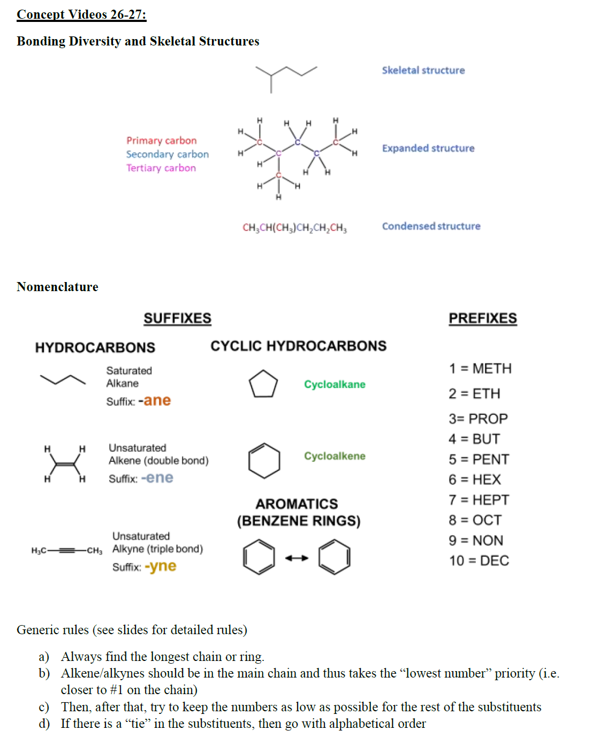

**Question 1. Naming and drawing molecules.**

1. Provide the molecular formula and draw the molecule as a skeletal structure.

|  |  |
| --- | --- |
| 2-pentyne | 3-chloro-3-methylcyclohexene |
| oct-3-en-5-yne | 1,4-dimethylcyclohexane |

1. Taking the iodo as your reference, indicate the position of the other substituents as *ortho, meta, para*.

|  |  |  |
| --- | --- | --- |
|  | **Group** | *ortho, meta, para* |
| fluoro |  |
| bromo |  |
| hydroxyl |  |
| methyl |  |

**Question 2. Carbon is a special atom – this is why we have a whole field dedicated to chemistry!**

1. Name this compound below and identify which carbon centres are primary, secondary, tertiary, or quaternary.

|  |
| --- |
|  |

1. Carbon can form bonds with itself as well as other elements.
2. In addition to the halogens, what 5 other atoms most *commonly* bond to carbon in organic compounds? (symbols or names are accepted)
3. Which of those 5 atoms in part *i* are heteroatoms?
4. From the 5 atoms in part *i*, which elements are more electronegative than carbon?
5. From the 5 atoms in part *i*, which elements are less electronegative than carbon?

**Question 3.**

a. Draw the following molecules as skeletal structures.

|  |  |
| --- | --- |
| *meta*-dichlorobenzene | 4-methylnon-6-en-2-yne |
| 4-bromopent-2-ene | 1-ethyl-4,5-dimethylcyclohex-1-ene |

b. How many units of unsaturation are there in Paxlovid, the Pfizer drug for COVID-19 shown below?



**Question 4.** For the following hydrocarbons, determine the degree of unsaturation (show your work) and draw one possible structure using skeletal structures.

|  |
| --- |
| i. C7H12 |
| ii. C8H12 |

**Question 5.**

1. Consider the following molecule.



i. Circle all the tertiary carbons in the structure provided.

ii. Provide the molecular formula of this molecule.

iii. Provide the systematic (IUPAC) name

**Question 6 Draw the following molecules.**

|  |  |  |
| --- | --- | --- |
| 2-methylhex-3-ene | 1-fluoro-2-methylpropane | ethylbenzene |
| 1-bromo-2,3-dimethylcycloheptane | 3-ethylcyclopent-1-ene | 1-fluoro-2-methylbenzene |

**Question 7 Draw as many examples of a hydrocarbon with 4 carbons and 1 unit of unsaturation. What is the molecular formula for each structure?**

**Question 8 Fix the problem with these structures by re-drawing them correctly. List what the problem was (briefly).**



**Question 9 Draw these expanded molecules as skeletal structures.**



**Question 10 Draw these condensed structures as skeletal structures.**

|  |  |
| --- | --- |
| (CH3CH2)2C=O | F(CH2)2CH(CH3)2 |
| Br(CH2)5C(CH3)3 | CH3CH(OH)CH2CH(CH3)2 |